Personal Comments : FRANK Thomas

· Section 1. Goals and Impacts:

Majority of consumer zappers, zap all sorts of insects.

<https://www.amazon.com/Zap-3-Layer-Rechargeable-Electric-Zapper/dp/B01JBU4WE4>

No bait, takes manpower to operate , battery power = limited usage b4 needs recharge.

>Overall i think our project should be powered from the wall, we need a source to keep the machine running, and provide enough voltage to induce spikes. From experience, batteries used in 323 die out pretty fast for our small application. Esp if we plan on using a display to show data or implement bluetooth communications.

<https://www.amazon.com/Flowtron-BK-40D-Electronic-Insect-Coverage/dp/B00004R9VW>

Zaps all bugs, due to uncontrolled killing it can create mist full of contaminants see PDF   
“Current Microbiology. Kansas State University.” Also uses UV light as bait, prolonged exposure to UV light has its own problems

We want to design something better… Killing female mosquitoes only causes less bugs exploding from zaps so substantially less contaminants going into the air.

Goal is to detect female mosquitoes using audio microphones, keep records on how many mosquitoes are detected and how many were zapped. Frequency detection helps prevent accidental discharge fewer discharges means lower overall power consumption.

Beneficial Societal Impact.

Reduce the number of harmful mosquitoes. Helps reduce the spread of diseases such as malaria and zika.

• Section 2. Background

Refer to study PDF “Current Microbiology. Kansas State University.”

Refer to ><https://www.gatesnotes.com/Health/Most-Lethal-Animal-Mosquito-Week>, .

Somewhat old data, optional source - <http://chronicle.augusta.com/stories/1997/04/14/tec_206798.shtml#.WEu1srIrKM9>

For instance, a study by the University of Delaware at Newark analyzed 13,789 insects zapped by electric traps and found only 31 - less than one-fourth of 1 percent - were biting bugs "seeking blood meals at the expense of homeowners."

<http://www.bugkiller.com.au/bugzappers.htm> SEE section -Electrocution of House Flies in Bug Zappers Releases Bacteria and Viruses James E. Urban, Department of Entomology, Kansas State University

“Our studies show that when Bug Zappers kill insects they stimulate the release of large numbers of bacteria or viruses which may be on the insect surface. “

More infomation - do bug zappers work - <http://www.mosquito.org/faq>

<https://entomologytoday.org/2015/10/26/male-mosquitoes-lured-to-traps-by-sounds-of-female-wing-beats/> - Female mosquites 484Hz

Previous/similar projects

Other project involve the use of lasers to track, analyze frequencies, and burn mosquitoes. Or the use of microphones to record mosquitoes and then analyze data later in labs.

2.2 Project Planning

3 main components - DSP, learning python for RasberryPi, Zappy part, Input Mic

3.1 Design Constraints

Overall system constraint, how fast can it respond vs layers/levels of filtering

And within the topic of filtering software vs hardware filtering

Component-level constraint, memory + sampling freq must be 2x

Proposal constraint - as per suggested by Westy in the proposal, Zappy part should get to 4kV

Other - FDA, make it bit more environmentally friendly by not using UV light. And meet health/pollution specifications by designing mesh/shield to not splatter .

Design something quiet to avoid unnecessary loud zapping (if applicable)

Cage around zappy part to prevent people or larger animals from accidentally zapping themselves.

3.2 Designs Considered

Static Low pass filter design:

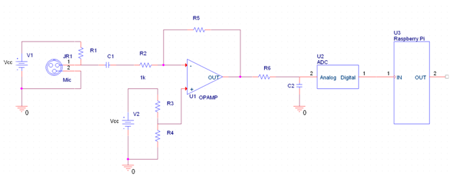

R1:Powers mic

C1:Blocks any DC component

R3,R4:DC offset

R5, C2: Low pass filter

R5 also protects against short circuits

Very simple and cheap to create.

Transformer component (zappy part):

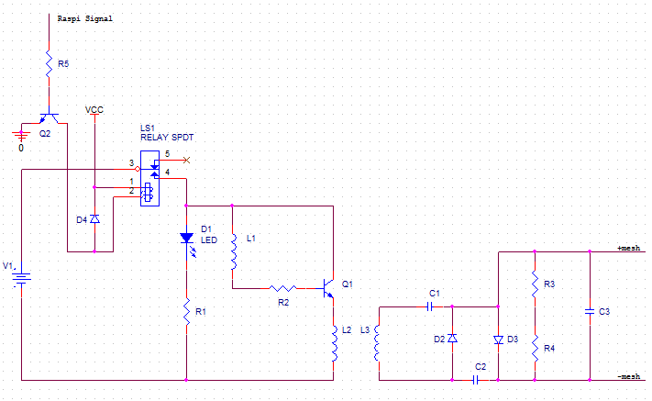

Panasonic WM-55D103 microphone since it is sensitive but has low noise. Lead free / RoHS Compliant. Has been proven to record mosquitoes before. <http://lib.dr.iastate.edu/cgi/viewcontent.cgi?article=1055&context=abe_eng_pubs>

data sheet:

<http://media.digikey.com/pdf/Data%20Sheets/Panasonic%20Electronic%20Components/WM-55D103.pdf>

4.2 Multi-Disciplinary Issue

EE designing analog circuit, CE design of program and working together to determine how best to input and output signals. We each have experience in pcb design, embedded system. Can assist Biology and Ecosystem fields in the analyzing and tracking of mosquitoes.